SIMATS ENGINEERING
ASSESSMENT TOOL 1: Concept Mapping

COURSE NAME: | Cloud Computing and Big Data Analytics | COURSE CODE: | CSA1522
Name | Shri Shanmuga Priya K
Register Number | 192324035

COURSE OUTCOME COVERED
CO1: Apply cloud computing technologies including hardware-software evolution, virtualization, web services, and service models to develop cloud-based solutions. (BL2)
Assessment Tool Weightage: 20%

Dave's Taxonomy: Imitation (Level 1)  Question Count: 4 | Total Marks: 50

Code of Conduct
I Shri Shanmuga Priya K 192324035 certify that this submission is my original work and that I have adhered to the guidelines specified for this assessment.
I understand that any violation of academic integrity rules will result in disciplinary action.
Signature of the student: 

Assessment Tasks
Concept Mapping Tasks
Create concept maps for the following tasks. Each map must show key nodes, link labels, and a logical hierarchy.
- Concept Map 1: Cloud Computing Fundamentals. Include definition, characteristics, benefits, and limitations.
- Concept Map 2: Evolution of Cloud Computing. Connect hardware evolution, internet software evolution, distributed systems, and service delivery.
- Concept Map 3: Service Models. Map IaaS, PaaS, SaaS, and XaaS with provider responsibilities and user responsibilities.
- Concept Map 4: Virtualization and Web Services as Enablers of Cloud. Show how these two concepts support cloud deployment and scalability.
Expected concept nodes:
- Elasticity, scalability, resource pooling, on-demand access, measured service
- Virtual machine, hypervisor, abstraction, API, SOAP, REST, provider, consumer
- Infrastructure layer, platform layer, application layer, shared responsibility

Concept Mapping Rubric

Criteria | Weightage | Level 4 - Exemplary | Level 3 - Proficient | Level 2 - Developing | Level 1 - Beginning
Concept Identification | 25% | All major concepts are accurately identified | Most concepts are identified correctly | Limited concepts are identified | Essential concepts are missing
Relationship Mapping | 25% | Links between concepts are accurate and meaningful | Most links are correct | Some links are weak or unclear | Relationships are mostly incorrect
Hierarchy and Organization | 20% | Excellent structure with clear hierarchy | Mostly organized with minor issues | Basic structure with weak hierarchy | No logical organization
Technical Relevance | 20% | Map strongly reflects cloud course content | Mostly aligned to topic | Partially aligned to topic | Weak alignment to topic
Visual Clarity | 10% | Neat, readable, and easy to interpret | Generally readable | Somewhat cluttered | Poorly presented

5. Questions
i). Evaluate the effectiveness of your concept map in representing cloud computing principles. Which design decisions most strongly support your solution, and why?
ii). Analyze how scalability, elasticity, and resource management influence the architecture shown in your concept map. What challenges could arise if these capabilities were absent?
iii). Justify the selection of the APIs, web services, or cloud services included in your concept map. How do they contribute to the overall functionality and efficiency of the system?
iv). Critically examine the relationships between the components in your concept map. How do these interactions improve reliability, performance, or user experience?
v). Reflect on the process of developing your concept map. How has creating and analyzing the map changed your understanding of cloud computing architecture, and what improvements would you make if you were redesigning it?

Concept Mapping Tasks
- Concept Map 1: Cloud Computing Fundamentals. Include definition, characteristics, benefits, and limitations.

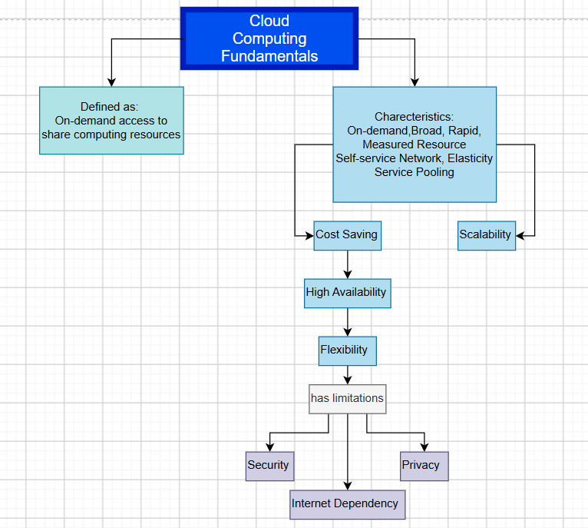
- Concept Map 2: Evolution of Cloud Computing. Connect hardware evolution, internet software evolution, distributed systems, and service delivery.

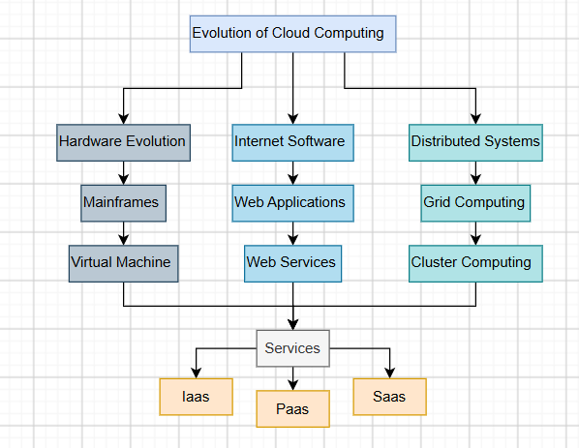
- Concept Map 3: Service Models. Map IaaS, PaaS, SaaS, and XaaS with provider responsibilities and user responsibilities.

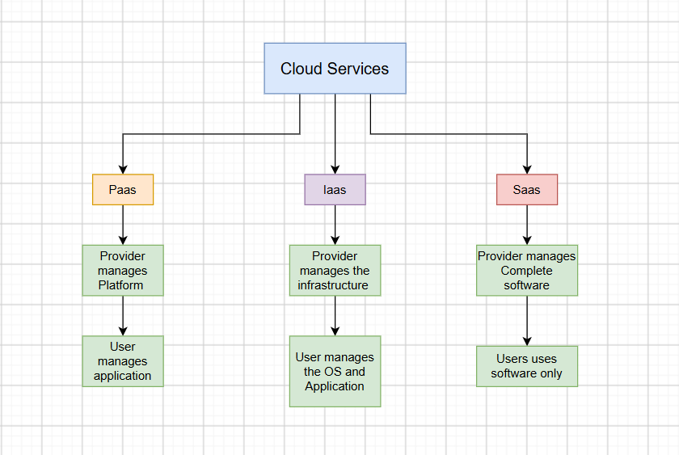
- Concept Map 4: Virtualization and Web Services as Enablers of Cloud. Show how these two concepts support cloud deployment and scalability.
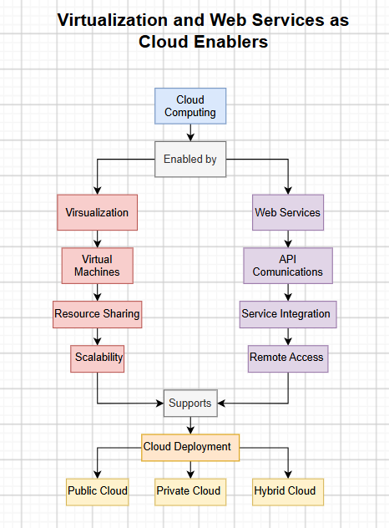

5. Questions
i) Evaluate the effectiveness of your concept map in representing cloud computing principles.
The concept map clearly shows the main cloud computing concepts and their relationships. Its hierarchical structure makes the topics easy to understand.

ii) Analyze how scalability, elasticity, and resource management influence the architecture. What happens if they are absent?
Scalability and elasticity allow resources to increase or decrease based on demand, while resource management allocates resources efficiently. Without them, the system may face poor performance, downtime, and higher costs.

iii) Justify the selection of the APIs, web services, or cloud services included in your concept map.
APIs and web services enable communication between applications, while IaaS, PaaS, and SaaS provide infrastructure, platforms, and software services. They improve flexibility and efficiency.

iv) Critically examine the relationships between the components in your concept map.
The components work together to provide reliable, scalable, and efficient cloud services. Their interaction improves performance and enhances the user experience.

v) Reflect on the process of developing your concept map. What improvements would you make?
Creating the concept map improved my understanding of cloud computing architecture and the relationship between its components. I would add deployment models and security features to make it more complete.

